Write a map only job for the word count program and set the output format as sequence file.

**Driver**

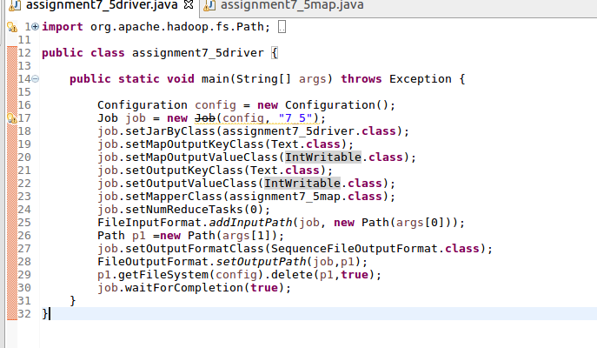

**Mapper**

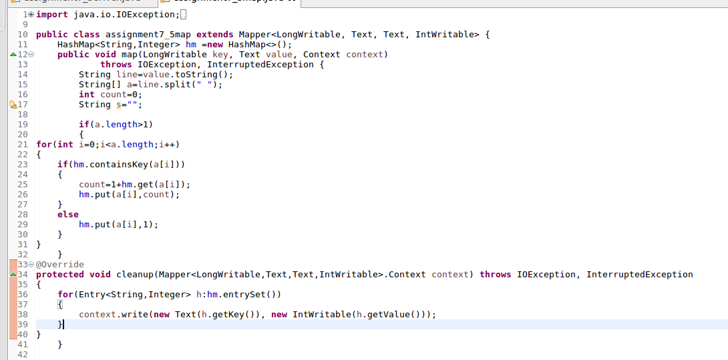

**Input File**

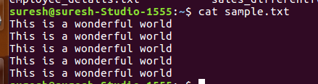

**Running jar**

**D:\assignment7\7.5run.png**

**Output file**

